Exact placement:
Step 1: do Q mask or (press shift + Q in gimp 3.2 for quick mask) , by selecting paint brush by P
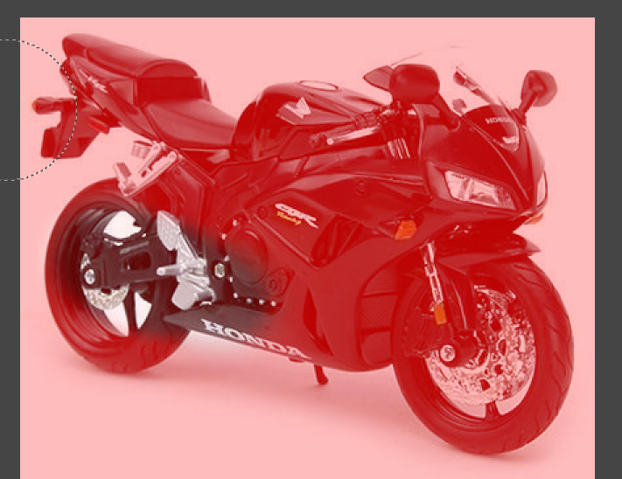
Step 2: select marching ants to have area for editing. Else go to Select -> invert to do background outpainting or scaling work.

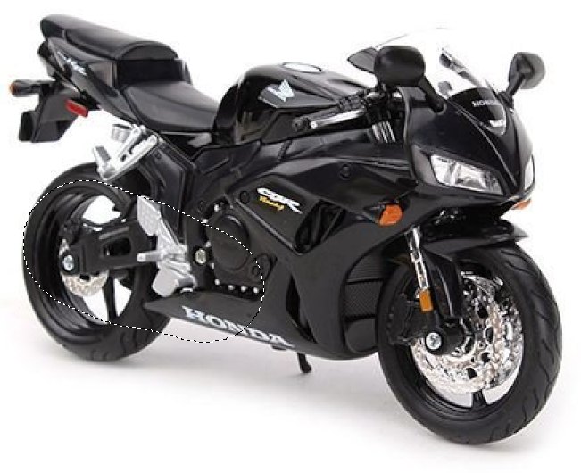
Step 3: when you enter the gemini prompt, note the coordinates. 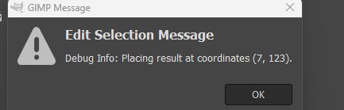
Step 4: Note that the selected pixel is to be their, don’t click anywhere outside.
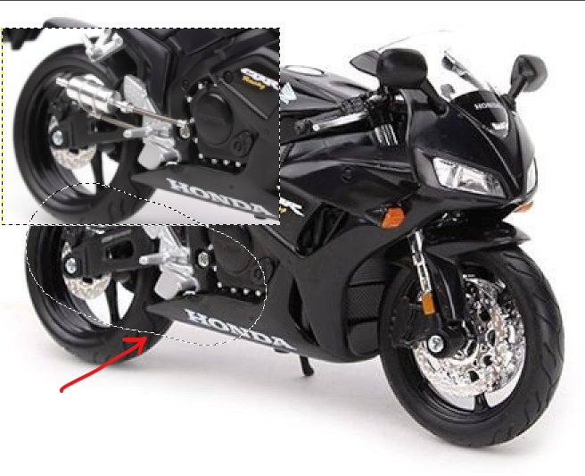
Step 5: Simply press R on keyboard and click on that selected area. It will create a bounding box. Note down the position and size coordinates: 7, 123, 208, 147. Then press escape. And then Ctrl+ Shift + A to unselect everything.
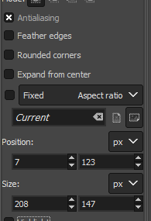
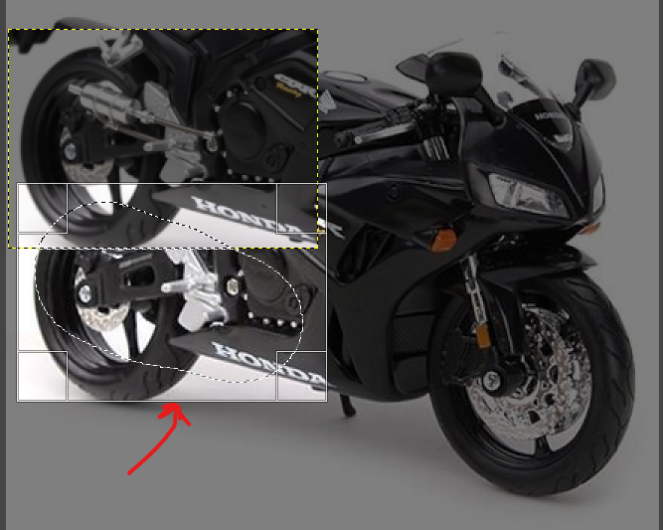
Step 6: Now click on “Gemini Edit” layer and press “ctrl + shift + v ” it will have the layer extracted to new tab
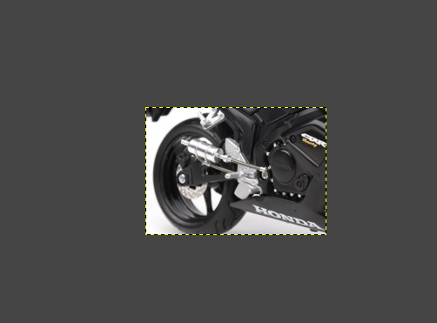
Step 7: Now add a new layer in between “Gemini Edit” and “Original Layer”.
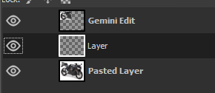
Step 8: Construct a rectangle with step 5 coordinates. Press R to construct. Then go to step 6 ctrl + c image in that tab. And on the layer tab selected in this tab, press ctrl v.
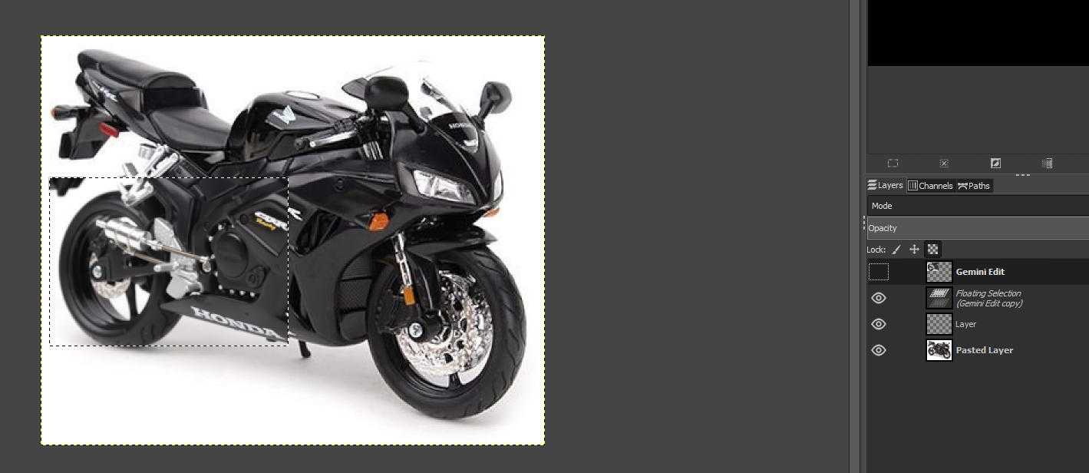

Step 9: you will see minor adjustments required either going only x or only y. Select layer -> press M -> click on image then move with keyboard arrow <- or -> . Then use SHIFT + S adjust scaling position
Press this anchor if floating is to be remove and layers can be adjusted.

